

2

1

4

5

6

7

8

9

10

11

12

|  |  |  |
| --- | --- | --- |
| **Numéro** | **Nom port** | **Périphériques** |
| **1** | Port ps2 souris | souris |
| **2** | Port ps2 clavier | clavier |
| **3** |  |  |
| **4** |  |  |
| **5** |  |  |
| **6** |  |  |
| **7** |  |  |
| **8** |  |  |
| **9** |  |  |
| **10** |  |  |
| **11** |  |  |
| **12** |  |  |

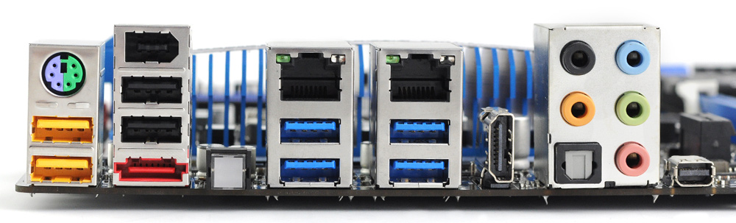

3

1

4

5

6

7

8

9

2

|  |  |  |
| --- | --- | --- |
| **Numéro** | **Nom port** | **Périphériques** |
| **1** |  |  |
| **2** |  |  |
| **3** |  |  |
| **4** |  |  |
| **5** |  |  |
| **6** |  |  |
| **7** |  |  |
| **8** |  |  |
| **9** |  |  |

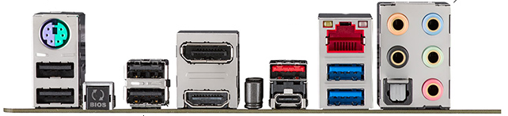

1

3

2

|  |  |  |
| --- | --- | --- |
| **Numéro** | **Nom port** | **Périphériques** |
| **1** |  |  |
| **2** |  |  |
| **3** |  |  |